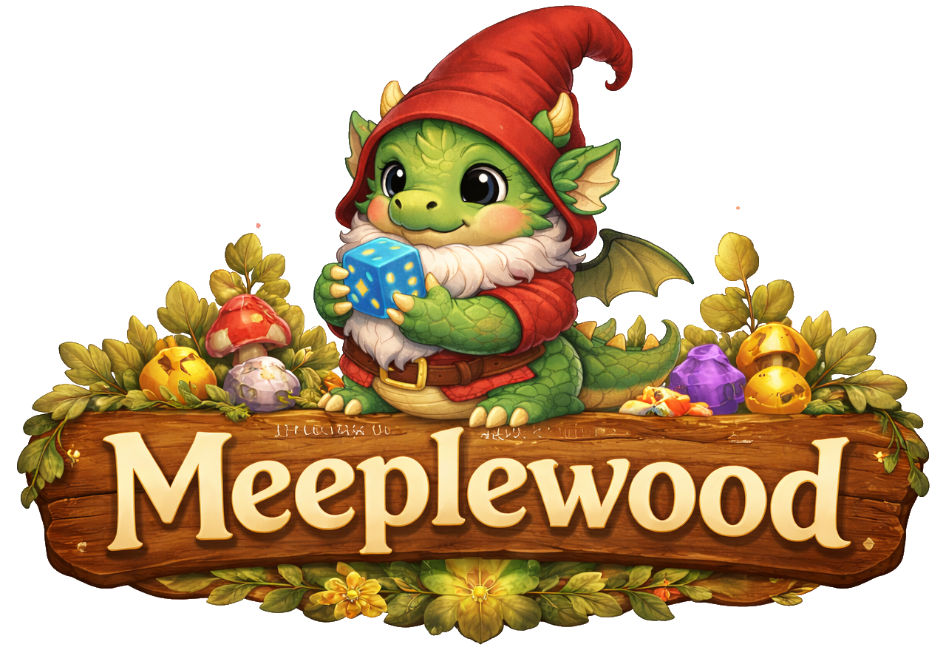
General Design
Table of content
Introduction 2
Project Overview 2
Intended Audience 2
Use of GenAI 2
Design Approach Overview 3
Combined Methods 3
Domain Situation 4
User Analysis 5
Primary user 5
Analysis of Existing Applications 6
Task analysis 7
Design Ideas 8
Use case model 9
UC.x 9
Lo-Fi Prototype UC.x 9
References 10

Introduction

Project Overview
Meeplewood is designed around several board game data sources, mainly logged plays from Board Game Stats (Eerko) and collection data exports from BoardGameGeek (BGG). The goal is to bring these data sources together in one place and turn them into useful insights and a playful way to explore the data for board game enthusiasts.
The application focuses on two main areas. First, it offers several ways to explore data about logged plays, such as identifying the most played games, play patterns with specific people, winners by game category or genre and might help answering the question “What to play next?” by suggesting games based on different criteria.
The second area is to help organize a board game collection by showing which games are owned, which games may already be covered by other people’s collections and which are on the wanted-list. This includes data from “Spiel preview lists" that are announced via BoardGameGeek every year before Spiel (Spiel).

Intended Audience
Meeplewood is a playful software experiment designed to explore programming concepts and experiment, both from a creative perspective and a software engineering perspective. It is a personal “because I can” and “practice what you preach” project.
As a teacher at the ICT Academy at Zuyd University of Applied Sciences, I teach students to develop various types of applications across different courses, with a strong focus on usability engineering and data visualization. Over the years, the idea for this project gradually took shape, and I decided to use it as an opportunity to build an application that follows the same guidelines and principles I expect from my students.
The first version therefore mainly serves my own use and personal development and is not intended to become a fully developed or widely deployed application. However, who knows what the future may bring.

Use of GenAI
AI is not a new phenomenon, but the launch of ChatGPT (ChatGPT) in 2022 changed the world. Instead of ignoring it, I try to use it to my advantage without losing a critical way of thinking and being creative. GenAI is used in this project for a number of reasons:
- Rewriting text: English is not my native language, so AI is used to rewrite text into a more formal and professional writing style.
- Generating images: Before GenAI, only very simple (and probably ugly) user interface elements would have been used. Image generation makes it possible to transform ideas and concepts into fun visual representations.
- Programming: As a software engineer, I already have coding experience and a solid understanding of basic software architecture concepts. This project is mainly used to explore programming concepts and languages that are new to me. AI tools such as GitHub Copilot help me understand unfamiliar concepts and assist in identifying and fixing errors during development.

Design Approach Overview
Depending on the course, different methodologies are taught to students. The design documents for this project follow a hybrid methodology that combines multiple approaches to create a cohesive development process tailored to this project.

Combined Methods
Nested Design Model provides the analytical foundation through three nested levels:
- Domain Situation: understanding the board game tracking context (playing and collecting)
- Data and Task Abstraction: identifying what questions can be answered with the data
- Visual Encoding: designing the visuals to help user answer the questions
Design Thinking drives the creative process:
- Empathize & Define: understanding user needs and pain points
- Ideate & Prototype: generating and testing solution concepts
Agile Development and ‘traditional’ Software Engineering:
- User Stories and iterative development for flexible feature delivery
- Use Case scenarios, UML diagrams, data normalization

Domain Situation
The modern board game world has evolved into a large and structured hobby ecosystem supported by online platforms, communities, and global events. Central to this ecosystem is BoardGameGeek, which functions as a comprehensive global database containing tens of thousands of board games, millions of ratings, and extensive user-generated data. The platform is widely used for recommendation systems, research, and community interaction, making it a key infrastructure within the contemporary board gaming hobby (Woodward & Woodward, 2019) (Xiao, 2025).
Board gaming is no longer limited to traditional family games played occasionally at home. Instead, it has developed into a complex and vibrant hobby characterized by specialized publishers, dedicated media and reviewers, large international conventions, online databases and tracking tools. Strong community interaction and knowledge sharing have further contributed to the growth of this ecosystem, allowing players to exchange experiences, discuss strategies, and evaluate new releases in a collaborative environment.
Board game conventions play a particularly important role in this landscape by bringing together players, publishers, designers, and retailers in large-scale events focused on playing, discovering, and selling games. Major conventions such as SPIEL Essen and Gen Con (Gen Con) attract tens to hundreds of thousands of attendees and serve as central meeting points for the global board game community. With thousands of new game releases presented each year, these conventions function as marketplaces for innovation and community gathering, demonstrating both the scale and the structured nature of the modern board game hobby.
As a result of these developments, the board game world has become a structured hobby environment in which players engage with games in multiple ways. Participation extends beyond simply playing games and includes collecting, reviewing, discussing and analysing them. This multi-layered engagement reflects the maturation of board gaming into a data-rich and community-driven domain, where information, interaction, and shared experiences are as important as gameplay itself.

User Analysis
Researchers are beginning to describe the demographics of board gamers (Cross, Piovesan, Sousa, Wright, & Atherton, 2023), but there is no single official hierarchy to describe a level of board gamer. The board gaming industry consistently recognizes a spectrum based on game weight, hobby involvement and/or complexity preference. For this project, the categories “Casual”, “Hobbyist”, ”Expert” and “Collector” will be used.
In a world full of data, a distinct subgroup has emerged: “data-driven board gamers”. These players are systematically tracking and analysing their board game activity. These players can be found in the category “casual”, but are more likely to be at least hobbyist players.
The existence of play logging features in platforms like BoardGameGeek and specialized tools such as Board Game Stats demonstrates that tracking and analysing gameplay data is a recognized and supported practice within the hobby.
The reason for logging plays and managing collections differs from person to person. An quick online search gave useful information on this topic, mainly forums where people discuss logging plays:
- BGG, January 2023 – Why do you log plays (or not)
- Reddit, June 2025 – Why do you track your plays?
- Reddit, January 2026 – How do you log your games
- BGG, Augustus 2023 – How do you log your games?
- Facebook, January 2026 – What tools do board gamers use to log plays?
Future versions may expand to serve other board game players and, in the far future, local board game stores might be able to use the tool for community features, board game discovery and recommendations. When this happens, a more elaborate user analysis should take place.

Primary user
Design Thinking is a user centred design method and a commonly used quote is “You are not the user”. In this case the developer is also the main and, in first versions, the only user. Therefor, this document will focus on features desired by the primary user only.
Characteristics:
- Receptivity to playful, themed interfaces when core functionality remains reliable.
- High technical proficiency and comfortable with file import/export operations (JSON, XLS).
- Strong interest in data insights, statistical analysis and content categorization.

Analysis of Existing Applications
- Functionality Comparison
- User Usability Evaluation
- Software Components and Architecture
- Strengths and Weaknesses
- Summary and Design Implications
Within the board game world, several applications are used to log play sessions, manage collections, and analyse board game data. The most influential and widely used platform in this domain is BoardGameGeek (BGG). Since its launch in January 2000, BoardGameGeek has grown into the central hub for board game information, offering a large user-generated database containing reviews, ratings, images, videos, forums, and play statistics for more than 150,000 board games. The platform has over 4 million accounts reported in 2025 and hundreds of thousands of active users contributing ratings and play data. This extensive database and active community have made BoardGameGeek the primary reference source for both hobbyists and researchers in the board game domain.
BGG provides a wide range of features, including game rankings based on user ratings, collection management, play logging, forums, and statistical insights such as number of plays, ownership, and user ratings. The platform’s ranking and rating system is widely used to evaluate board games, with popular titles receiving tens of thousands of recorded plays annually. For example, in 2024 the game Ark Nova recorded over 100,000 logged plays on the platform, demonstrating the scale and activity of the BGG ecosystem.
While BoardGameGeek serves as the central data and community platform, specialised applications have emerged to improve play tracking and statistical analysis. One of the most prominent of these is BGStats, a dedicated mobile application focused on logging plays, tracking collections, and analysing gameplay statistics. BGStats allows users to record play sessions, track scores, analyse player performance and generate statistical insights through graphs and reports, while synchronising data with BoardGameGeek. The application is available on both iOS and Android and has accumulated tens of thousands of downloads and thousands of user reviews, indicating a strong adoption within the board gaming community.
The key difference between the two platforms lies in their primary focus. BoardGameGeek functions as a large-scale community-driven database and information hub, while BGStats focuses on personal play tracking and statistical analysis with a user-friendly mobile interface. Together, these applications illustrate the current landscape of board game software: a central data platform complemented by specialised tools that enhance usability, play tracking and personal analytics.
This section analyses these existing applications in more detail to identify their strengths, limitations, and opportunities for improvement, forming the foundation for the design and development of Meeplewood.

Boardgamegeek
Sdf

BGStats
Sdf

Task analysis
Typical functionalities for data-driven gamers include logging every game played; tracking players, scores, wins and losses; recording playtime and locations; managing and analysing their game collection; monitoring play frequency and trends; using statistics to evaluate their gaming habits; integrating tools and databases into their hobby. For these players, board gaming becomes both a social and analytical activity.
Define:
- Which tasks are core vs. supporting.
- Task decomposition.
- Task-to-feature mapping.
- User Stories

What tasks users perform:
- Maintain a comprehensive overview of their board game collection.
- Identify patterns in play frequency, wins, and player preferences.
- Streamline game selection to reduce decision friction.
- Experiment with novel features for personal enjoyment.

Design Ideas
- Theme
- Overall look -and-feel

Use case model
- UC-Diagram and overall description

UC.x
Use Case​ | <Unieke code>: <Unieke, beschrijvende naam voor de use-case>​
Beschrijving​ | <Korte beschrijving (max 5 zinnen) die uitlegt wat de UC doet>​
Actor(en)​ | <Welke Actor/Actoren voeren deze use-case uit?>​
Trigger(s)​ | <Situatie(s) waaronder de use-case wordt gestart, meestal gelijk de 1e stap>​
Pre-conditions​ | <Optioneel; Alle voorwaarden, die noodzakelijk waar zijn voordat de use-case wordt gestart>​
Post-conditions​ | <Wat is het resultaat van een succesvol verloop van de use case>​
Steps​ | <stappen die uitgevoerd (kunnen) worden tijdens de use-case. ​  Links = acties vanuit de actor; rechts = acties vanuit het systeem>​
 | 1. ​  3.​  4.​  …​ | 2.​  5. ​
Main Succes Scenario​ | <volgorde van stappen voor het belangrijkste (meest voorkomende) succesvolle scenario>​
Alternative Scenario’s​ | <volgorde van stappen voor alle overige scenario's ; geef telkens een naam voor het scenario en of deze wel of niet succesvol is>​

Lo-Fi Prototype UC.x

References
BGG. (n.d.). Retrieved from https://boardgamegeek.com/
Boumans, R. (2026). Github repository. Retrieved from https://github.com/Excali8ur/Meeplewood
ChatGPT. (n.d.). Retrieved from chatgpt.com
Cross, L., Piovesan, A., Sousa, M., Wright, P., & Atherton, G. (2023). Your move: An open access dataset of over 1500 board gamer’s demographics, preferences and motivations. Simulation & Gaming, 54(5), pp. 554-575.
Eerko. (n.d.). Board Game Stats. Retrieved from https://www.bgstatsapp.com/
Gen Con. (n.d.). Retrieved from https://www.gencon.com/
LinkedIn Profile. (n.d.). Retrieved from LinkedIn: https://www.linkedin.com/in/rianneverheijen/
NemeStats. (n.d.). Retrieved from https://nemestats.com/
Spiel. (n.d.). Retrieved from https://www.spiel-essen.de/en/
Woodward, P., & Woodward, S. (2019, Oktober). Mining the Boardgamegeek. Significance, pp. 24-29.
Xiao, T. (2025). Analysis of Factors Influencing Board Game Ownership Based on A Gradient Boosting Model. Theoretical and Natural Science, pp. 16-24.

